1. **Agenda:**
   1. At the time of MS startup, it should create topic.
2. Good practice to create topic first, before sending 1st msg.
3. 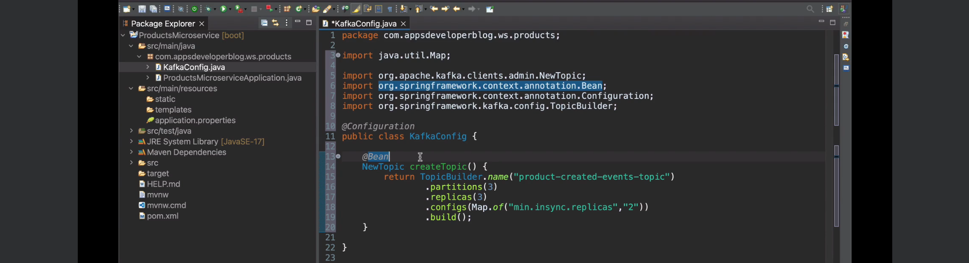
   1. KafkaConfig class will contain Kafka-related beans configuration.
   2. **Partition benefits**
      1. Parallel Processing.
      2. Scalability. (Jatin: As more partition allows more brokers).
      3. Throughput of system increases as multiple consumers can consumer from the same topic.
   3. **# of Replica**:
      1. If it is 3, then 3 copies of each partition.
      2. One replica on each broker.
      3. If 3 replicas, then there must be 3 brokers.
      4. Increasing # of replicas also increases the storage requirement & network traffic b/w brokers.   
         So good to have reasonable number.
   4. **min.insync.replicas**:
      1. The number of replicas that must acknowledge the write operation for this write operation to be considered successful.  
         As we have to wait for replicas to acknowledge that they have received information, it makes writing to a topic a bit little more slower, but it gives us guarantee that our data is stored more reliably.